**Phase-End Project**

**EMS Full Stack App-Requirement**

**Screenshots:**

**GET:(Displays all Employee details)**

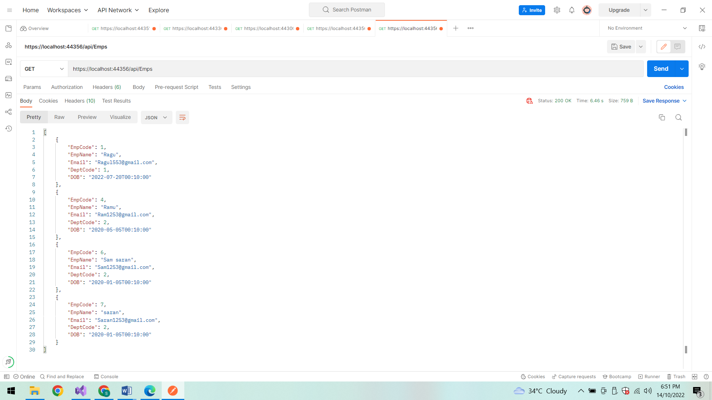

**DELETE Method:**

Delete based on Employee Id:

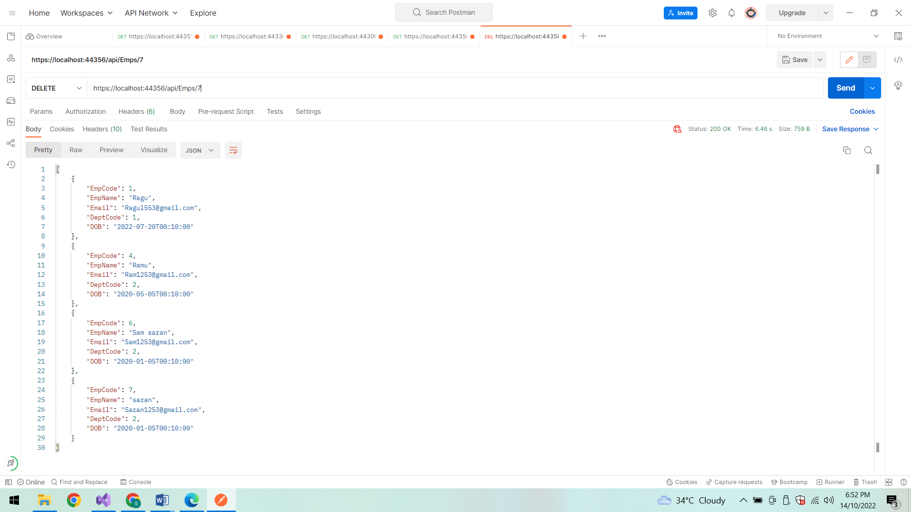

**Status code After deletion:**

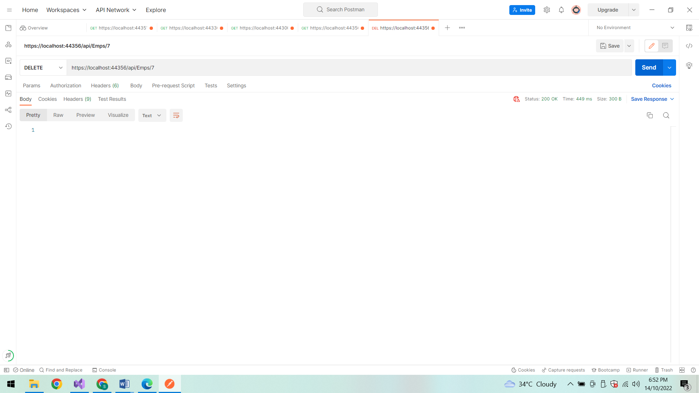

**After deletion:**

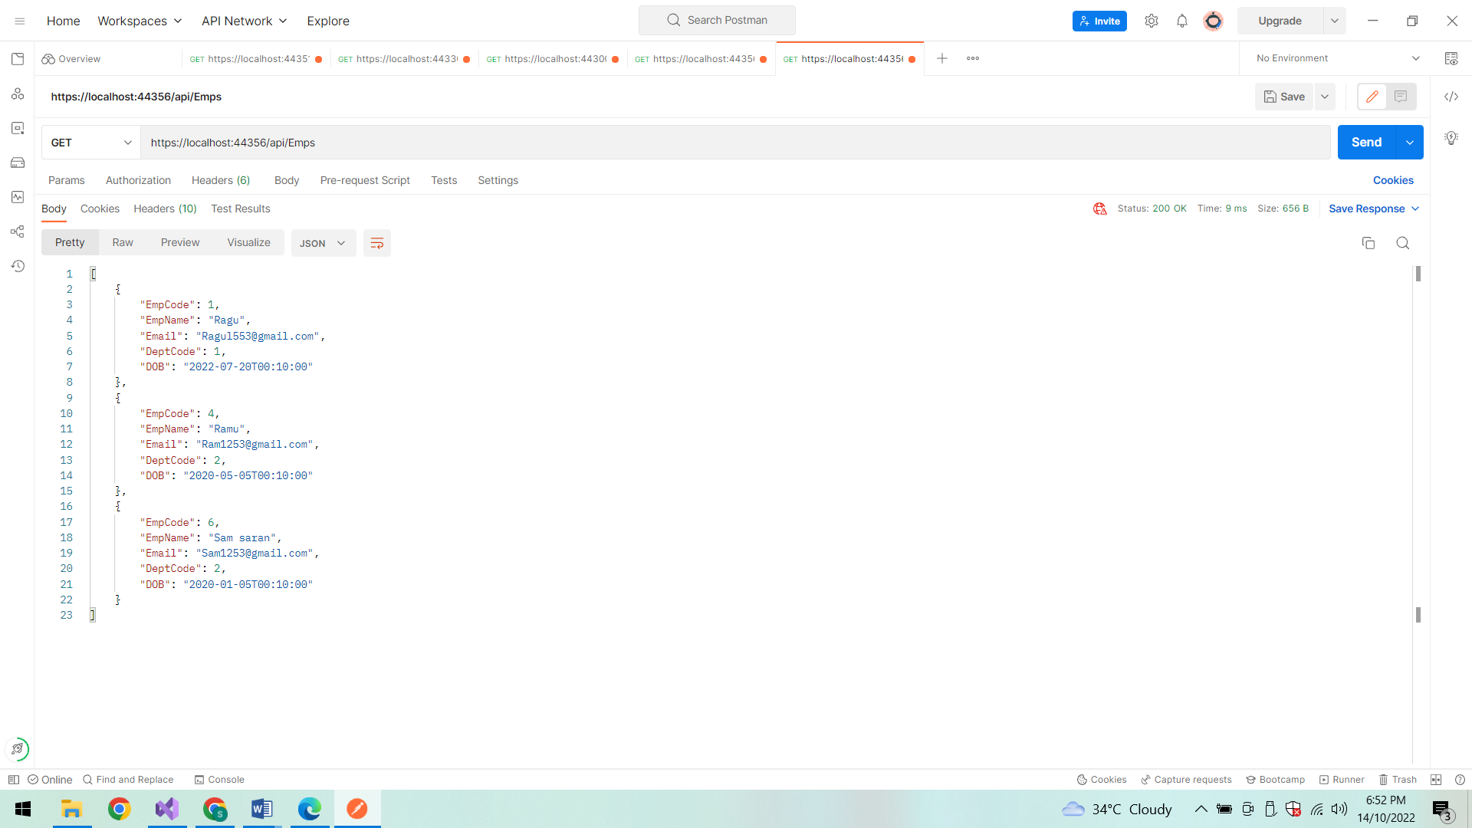

**POST Method:(To insert data in the database)**

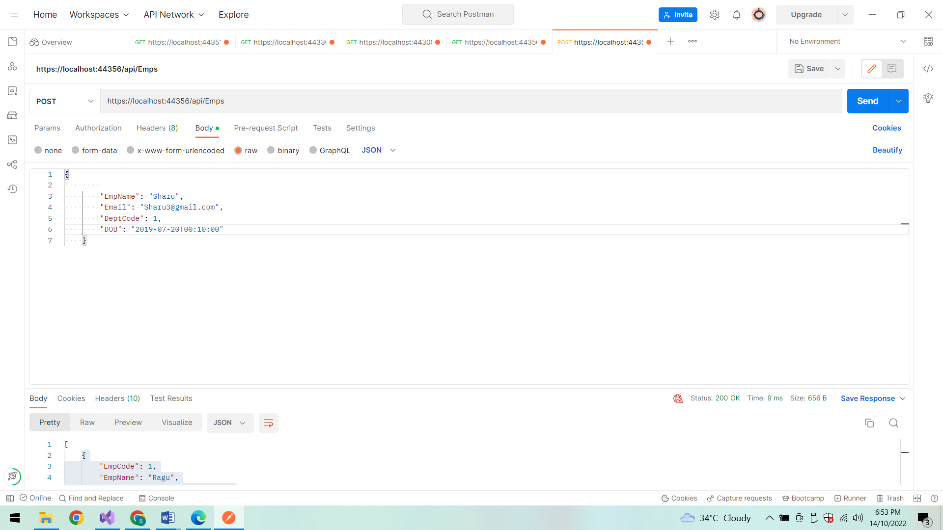

**Status code:**

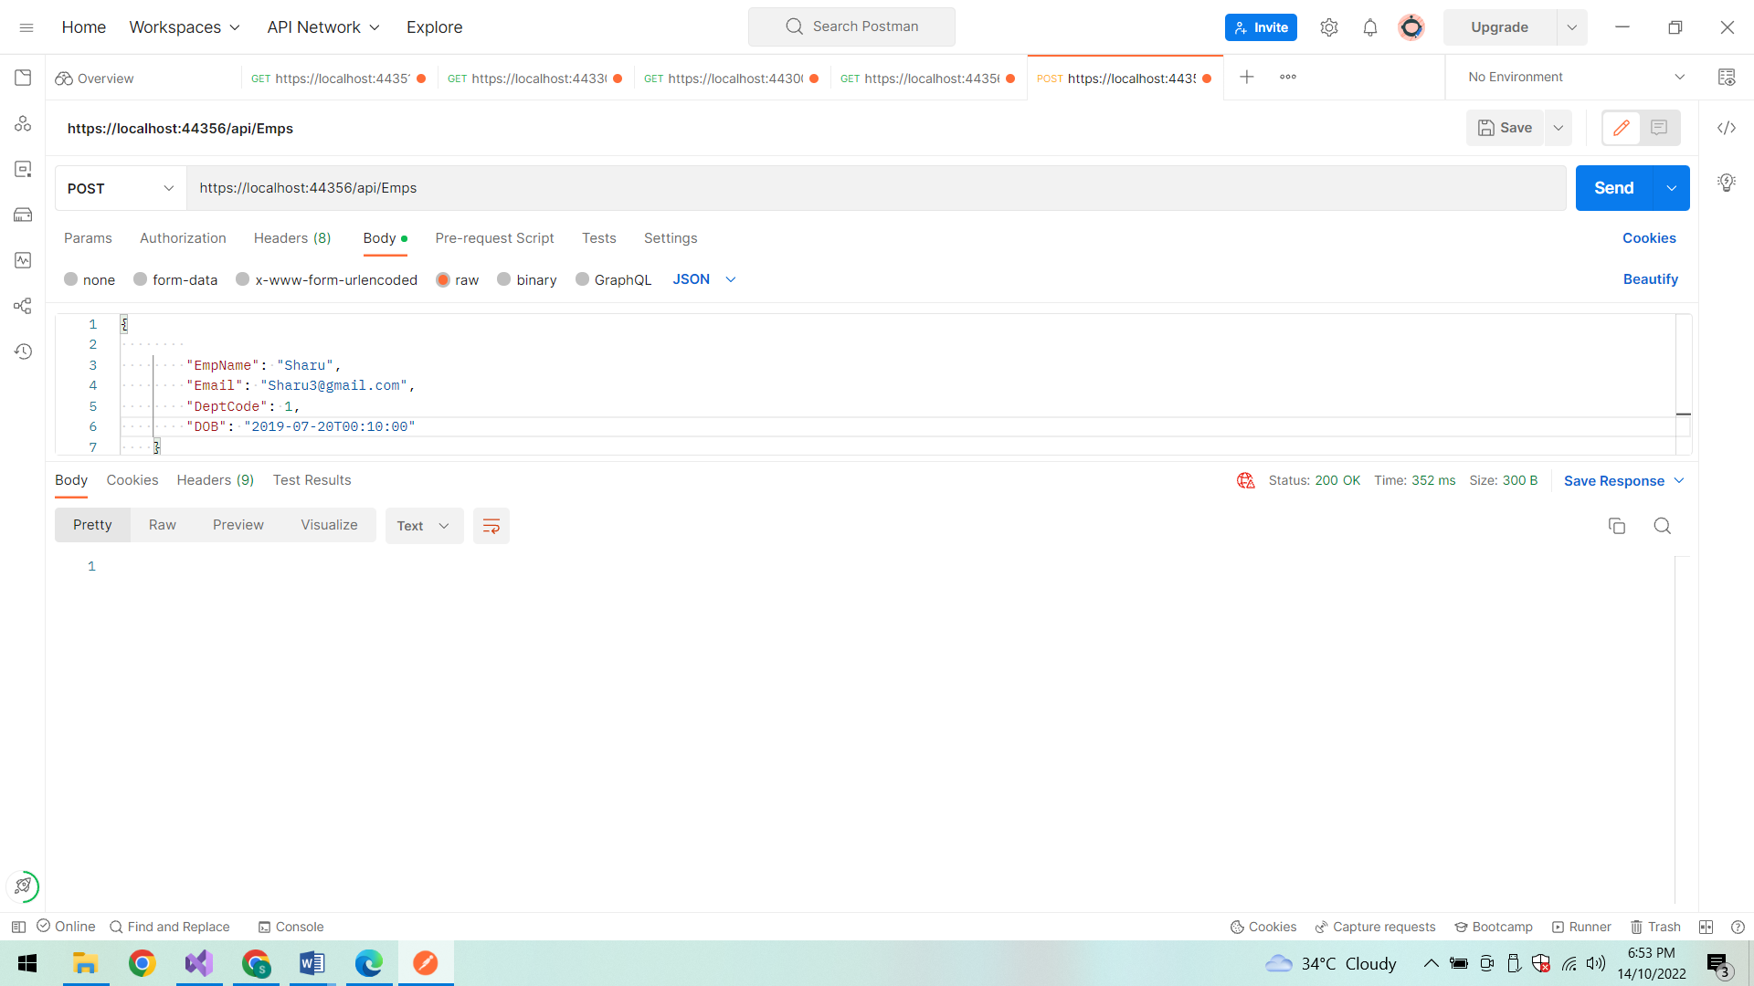

**After Insertion the Employee details are displayed:**

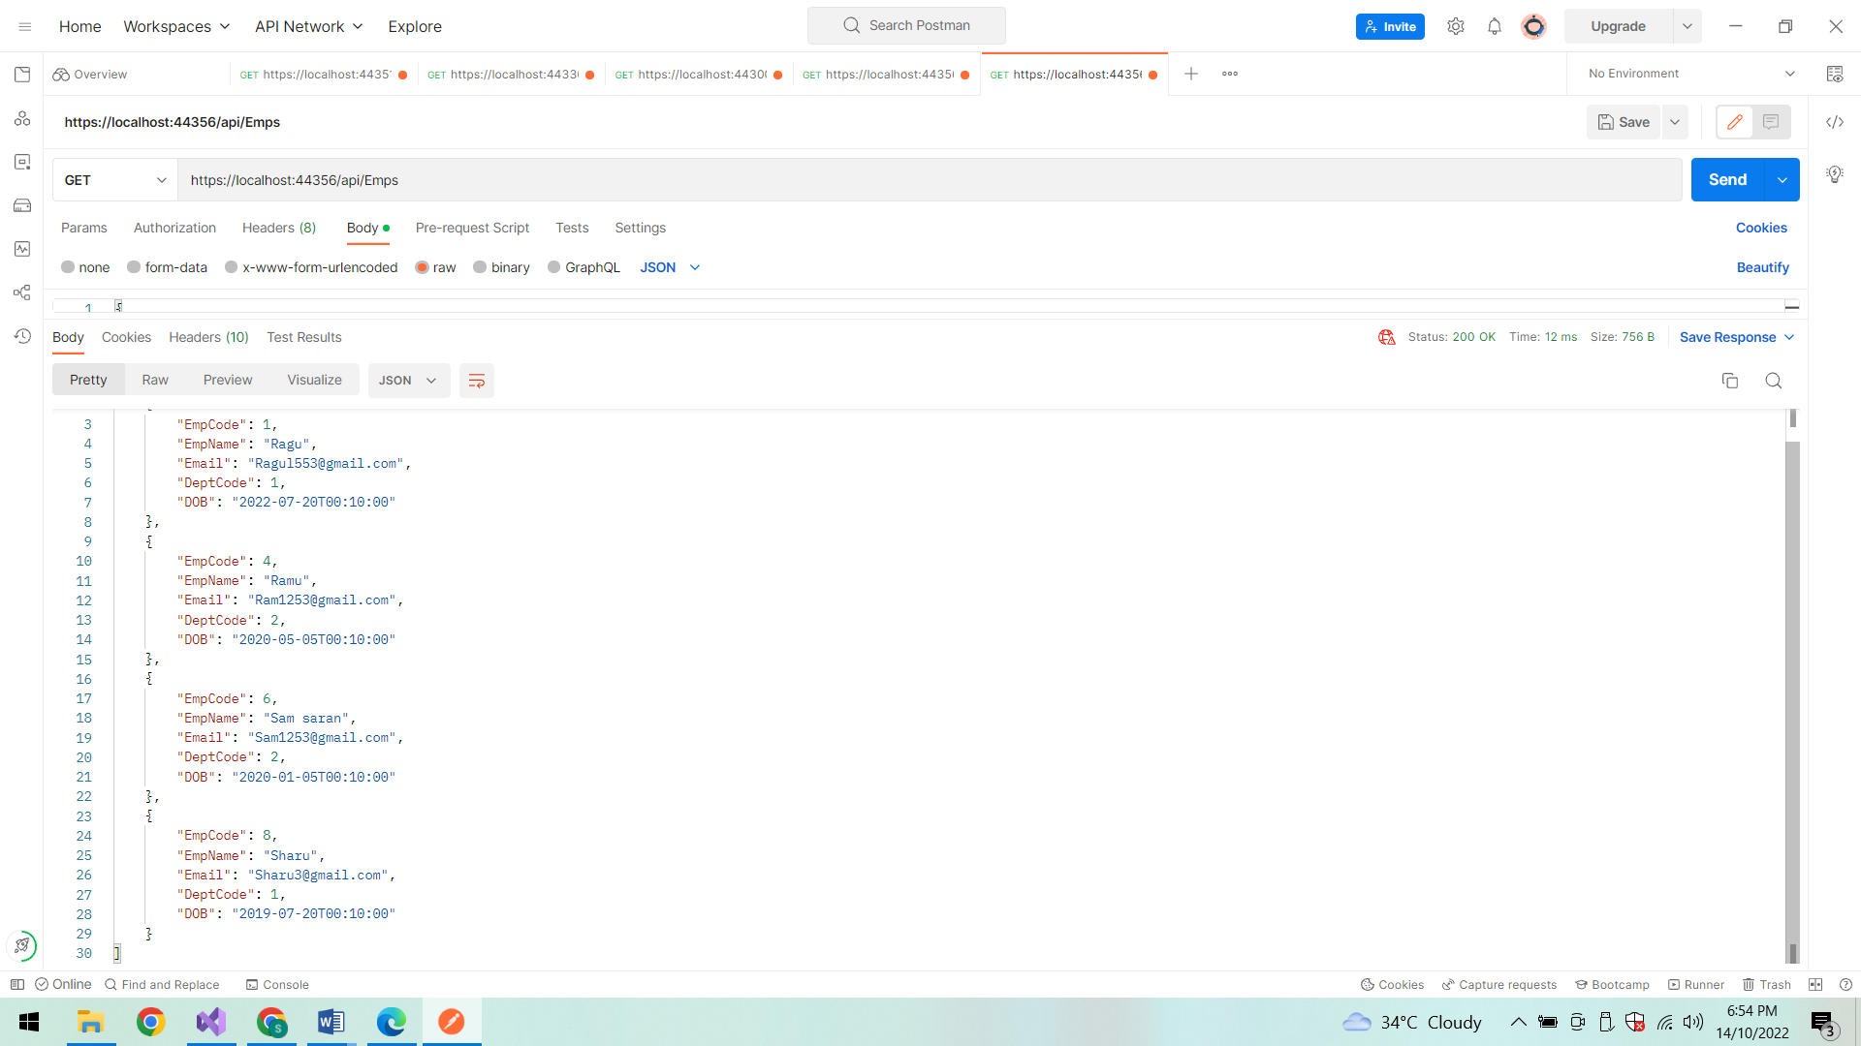

**PUT method:**

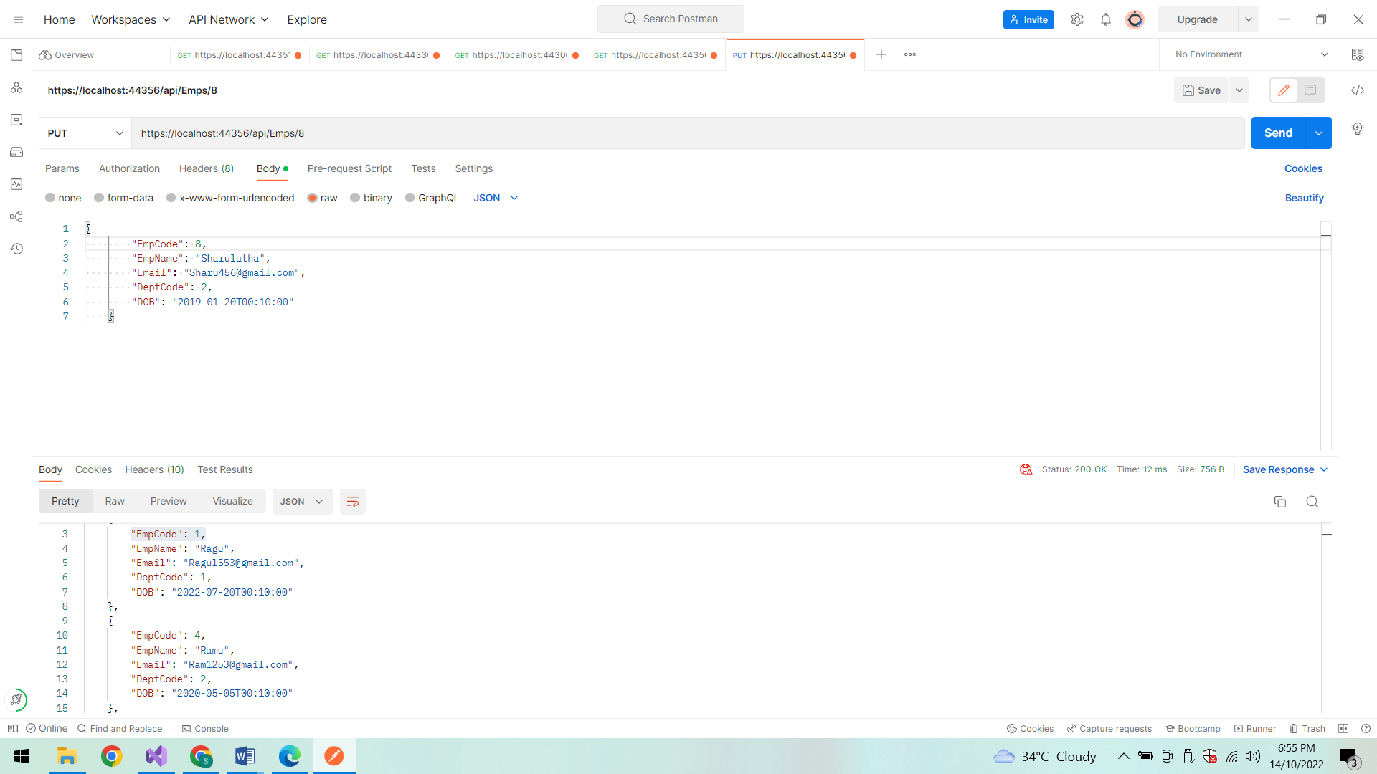

**Status code:**

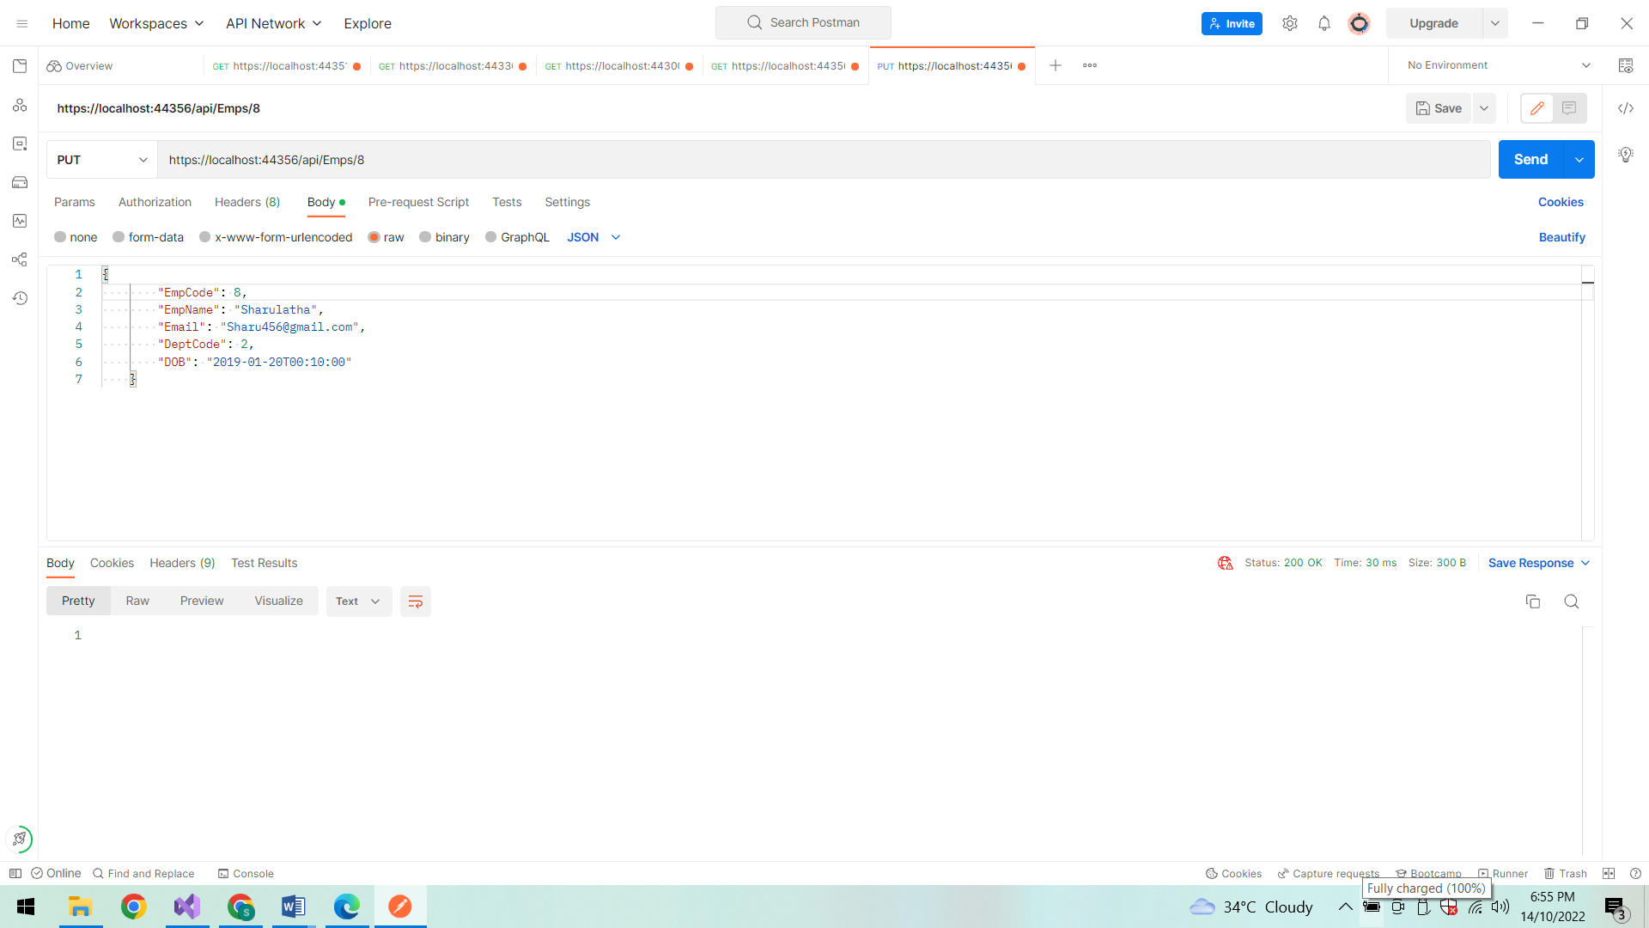

**After Updation:**

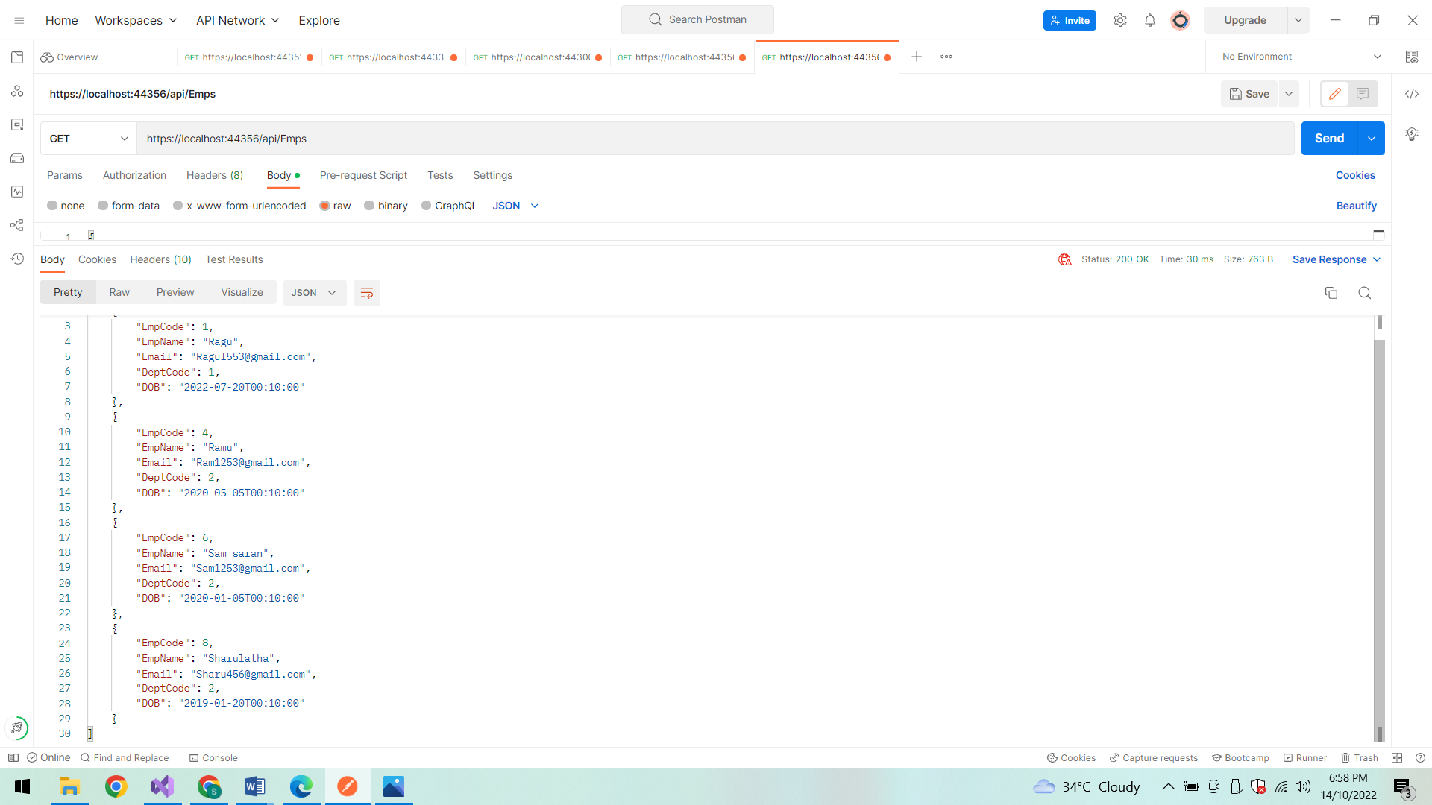

**FindById:**

Search Employee details based on EmpCode

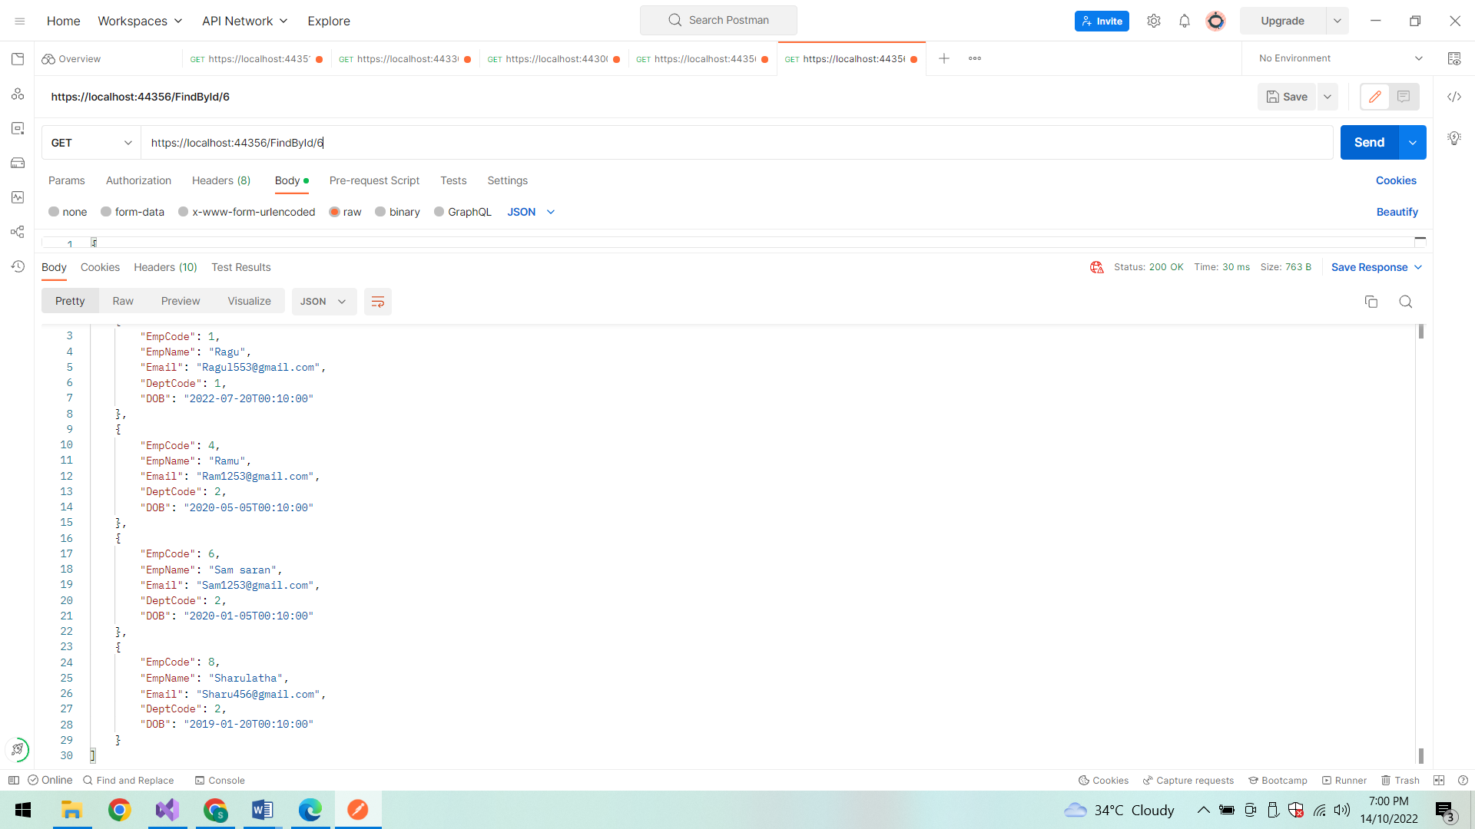

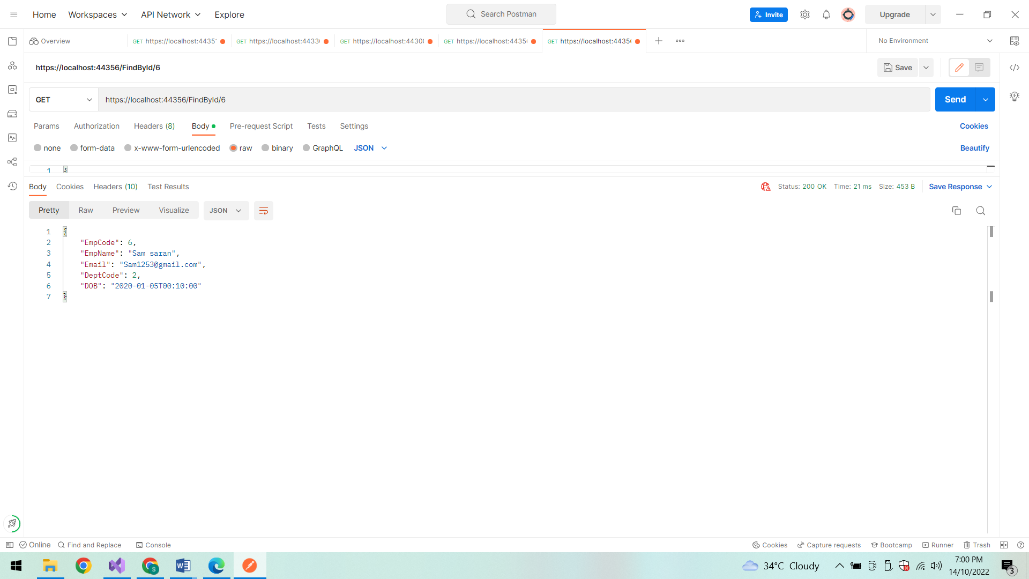

**FindById :**

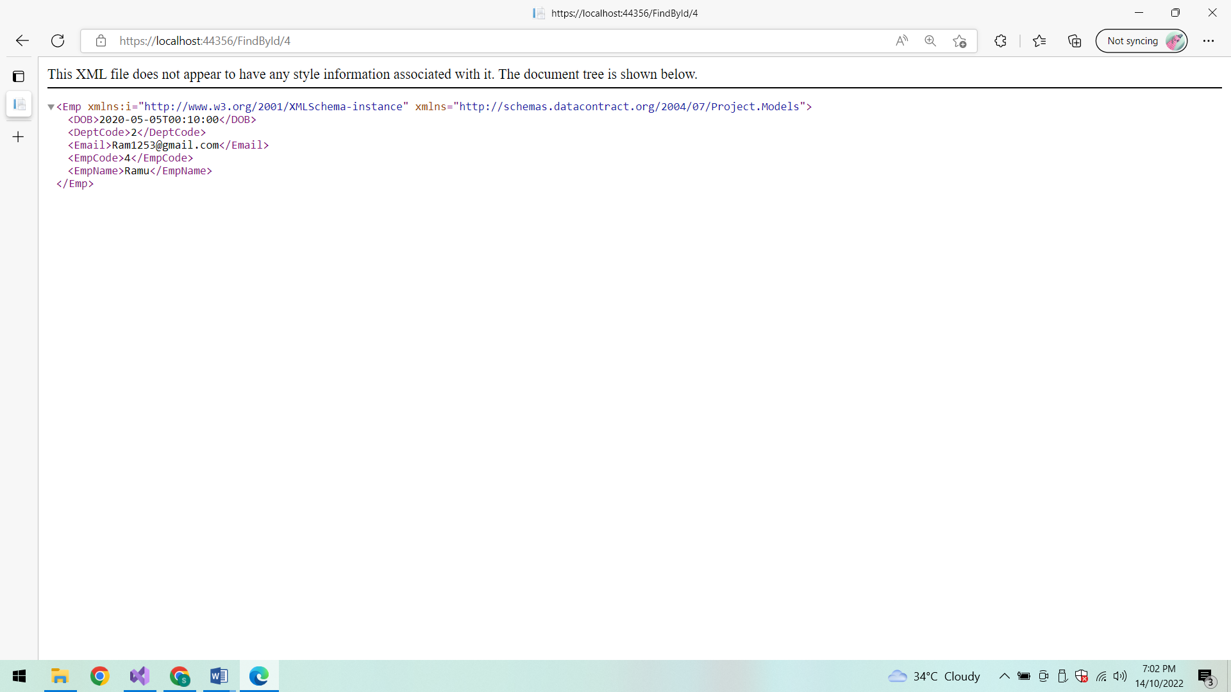

**Show All Employee details:**

**In PostMan:**

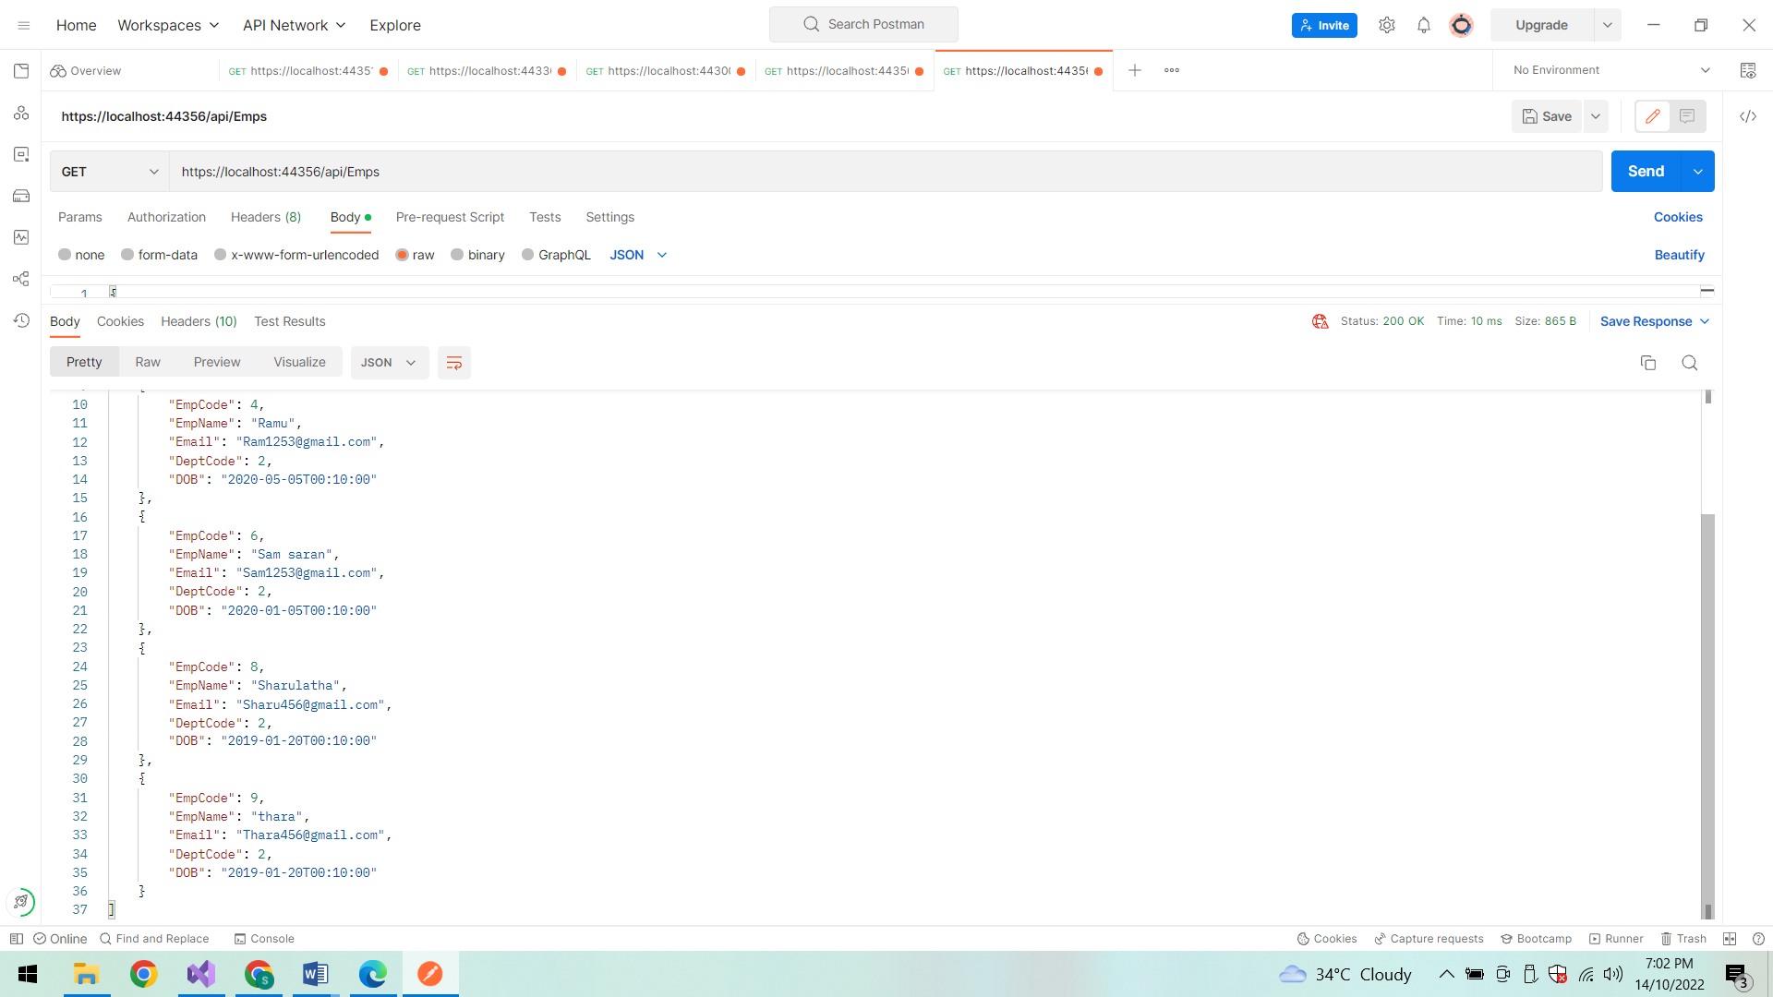

**In LocalHost:**

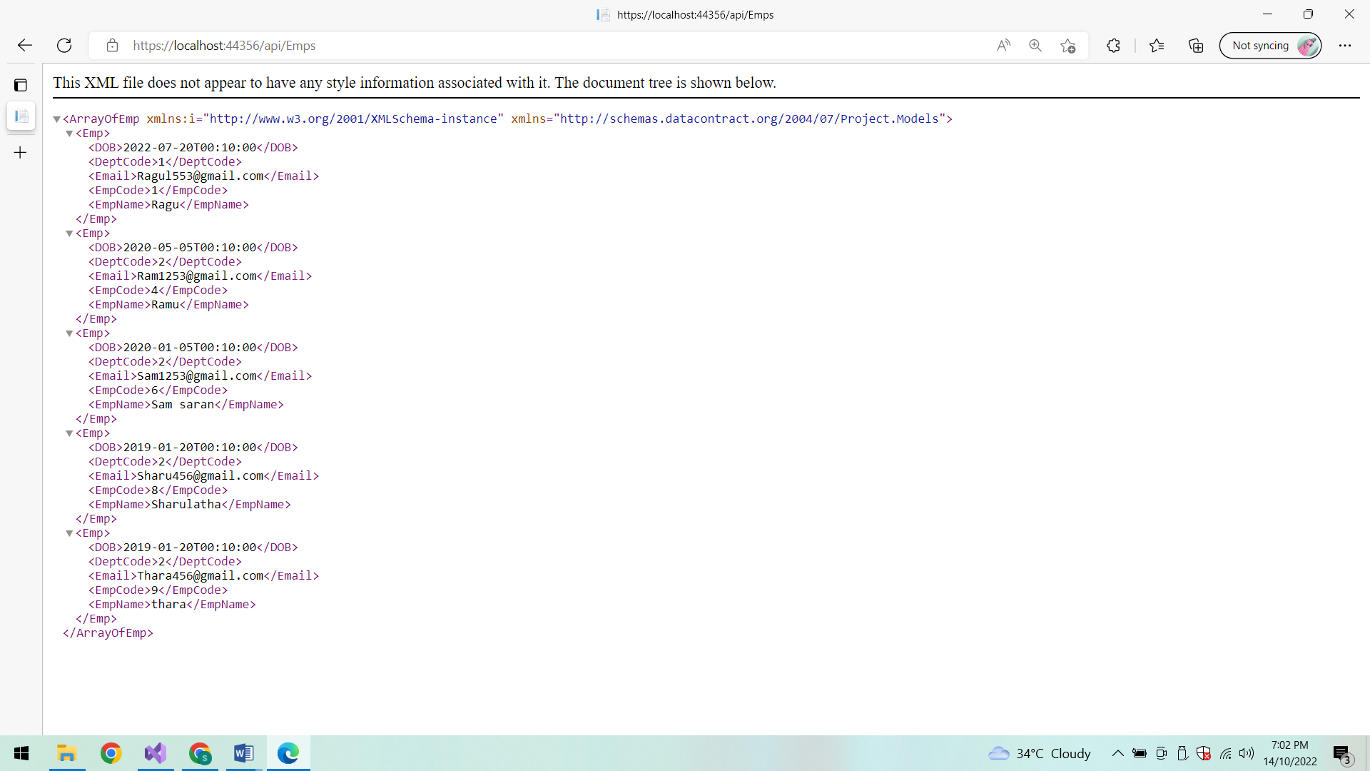

**Database:**

**EmpProfiles:**

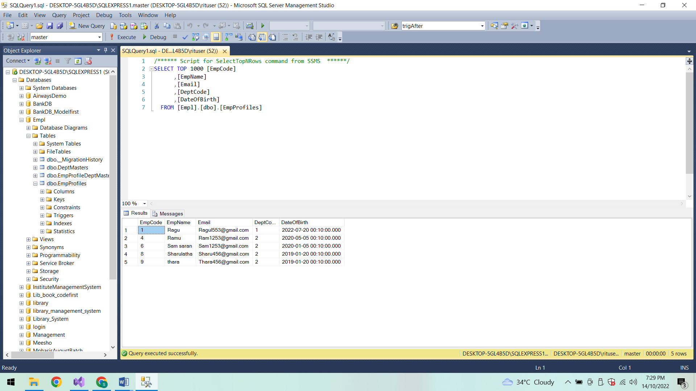

**DeptMasters:**

